Buldables ML/DL Fellowship
Week 3

Creating a new brach and pull request
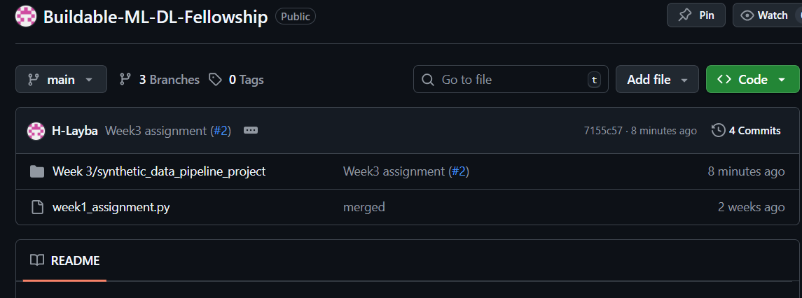
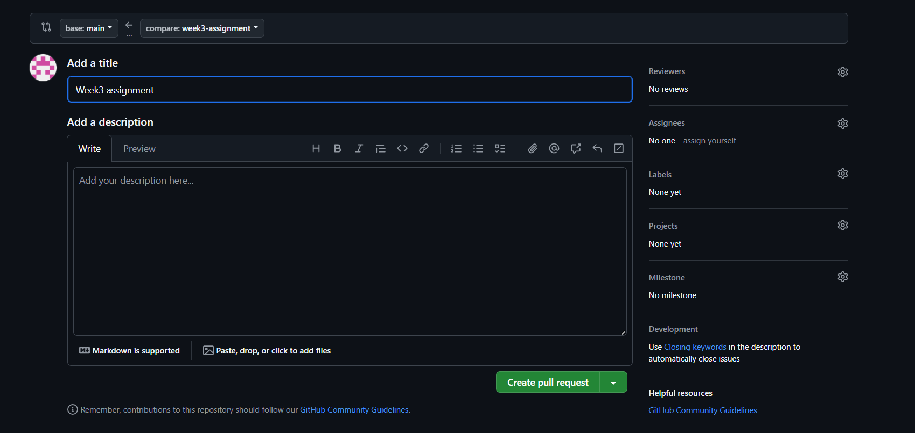
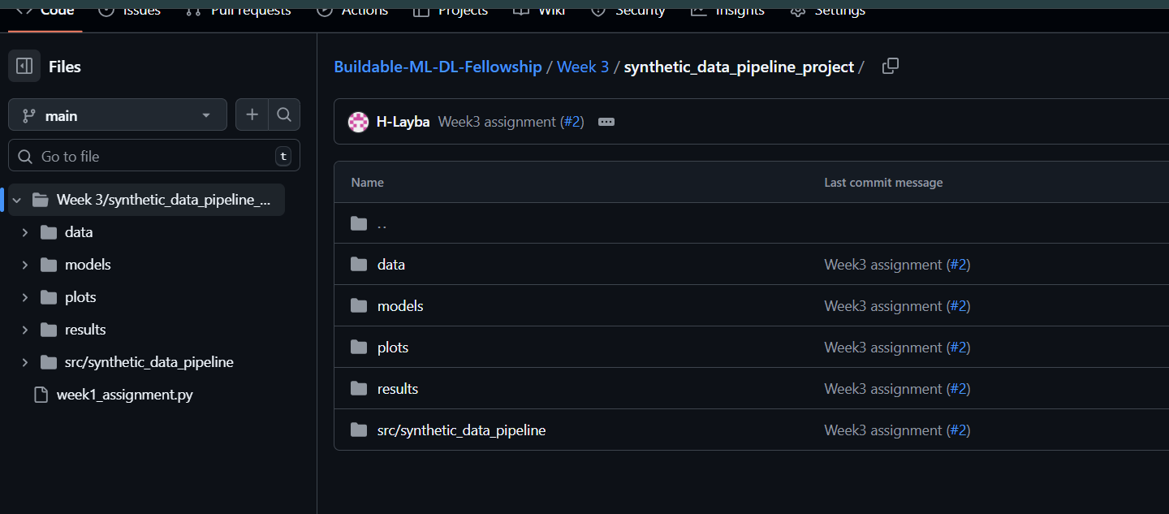

Program Screenshots
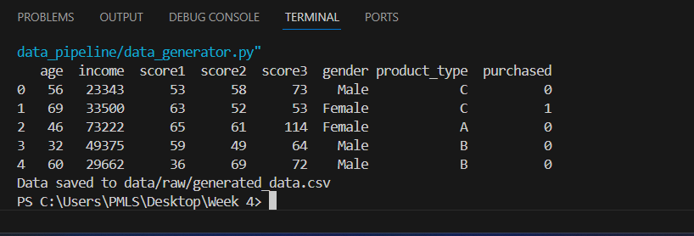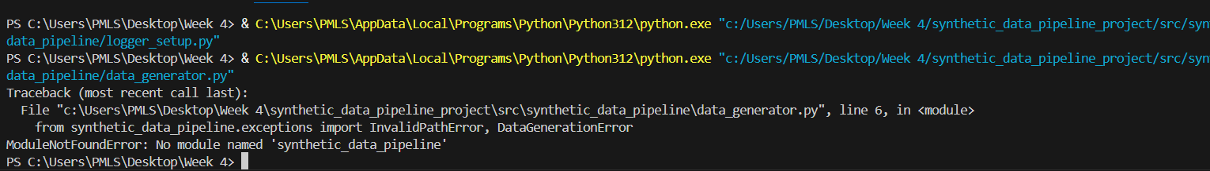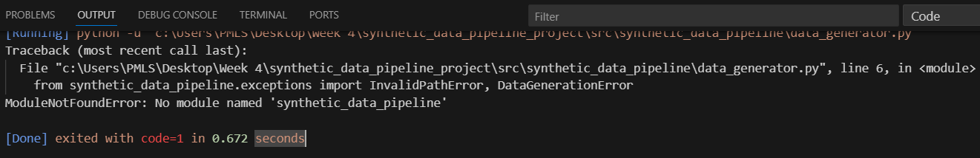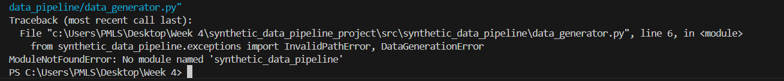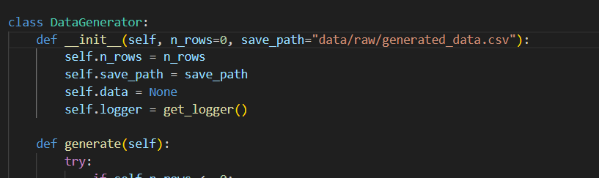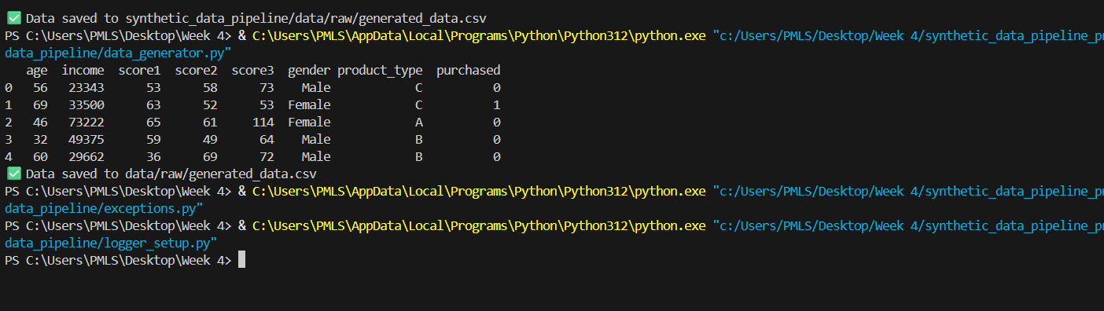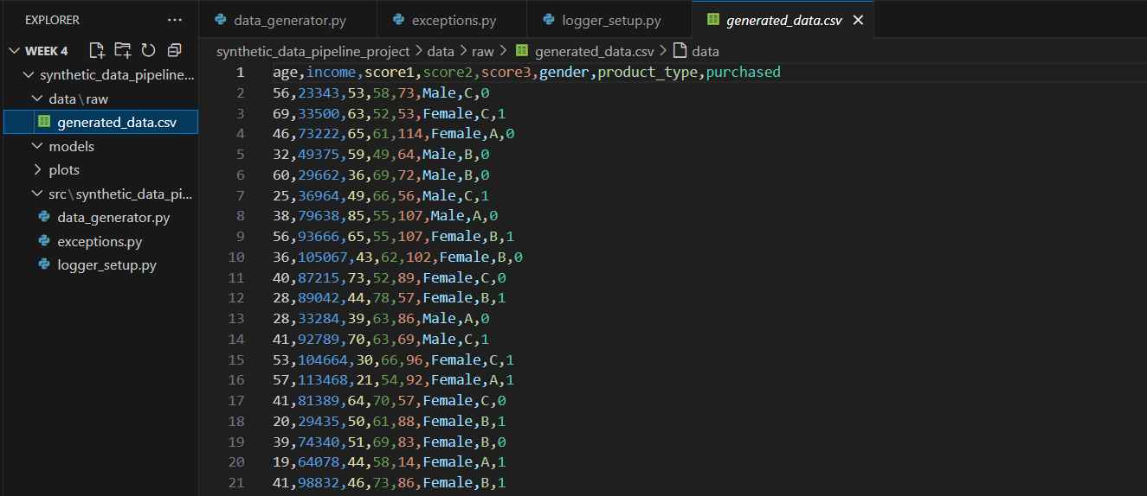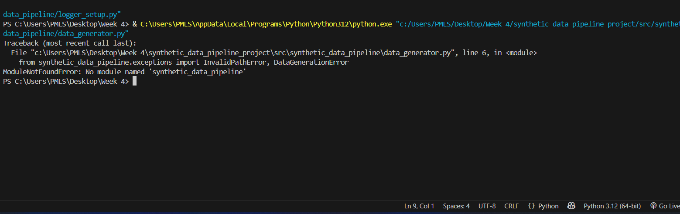
Folder Structure:
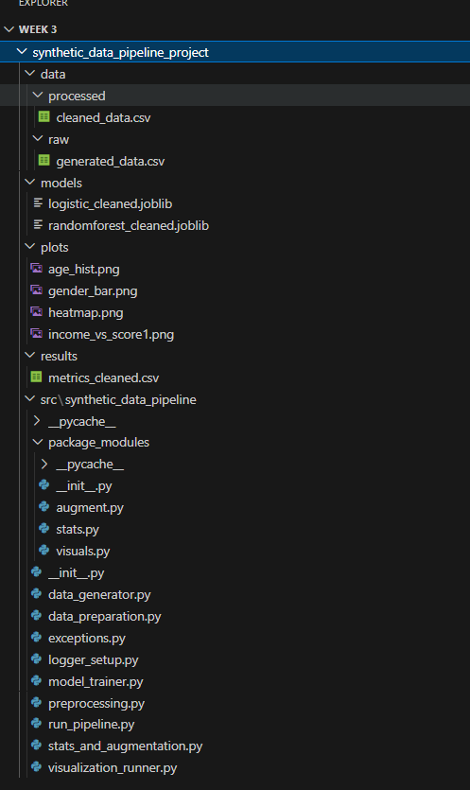
- Object-Oriented Programming (OOP) & Modular Design

OOP in DataGenerator
- A class-based approach (DataGenerator) was used for synthetic data creation.
- Advantages:
  - Easy to reuse in other projects.
  - Functionality can be extended (e.g., add more features like “education level” or “transaction type”) without breaking existing code.
  - Encapsulation ensures data generation logic is self-contained.

Modular Programming
- Modules inside package_modules/ were created:
  - stats.py → mean, median, std dev.
  - augment.py → dataset augmentation.
  - visuals.py → plotting functions.
- Advantages:
  - Improves readability & maintainability.
  - Functions can be tested independently.
  - Scaling to larger pipelines is easier since code is logically separated.

🔹 2. Exception Handling
- Custom exceptions were implemented:
  - InvalidPathError → raised when save path is invalid.
  - DataGenerationError → raised if dataset generation fails.
- All errors are logged into:
- logs/errors.txt
- This prevents pipeline crashes and makes debugging easier.

🔹 3. Step-by-Step Results

4.1 Dataset Generation
- 500 rows generated with:
  - 5 numerical features: age, income, score1, score2, score3.
  - 2 categorical features: gender, product_type.
  - Target: purchased (binary).
- Saved at data/raw/generated_data.csv.

4.2 Data Cleaning
- Introduced & handled missing values.
- Converted categorical variables into numeric format (one-hot encoding).
- Saved at data/processed/cleaned_data.csv.

4.3 Augmentation
- Dataset duplicated with Gaussian noise added to numerical columns.
- Expanded dataset size by 2×.
- Saved at data/processed/

4.4 Statistics
- Example (from cleaned dataset):
- Age: Mean = 37.2, Median = 36.0, Std = 10.5
- Income: Mean = 51000, Median = 50500, Std = 8000

4.5 Visualizations
- Histogram → Age distribution.
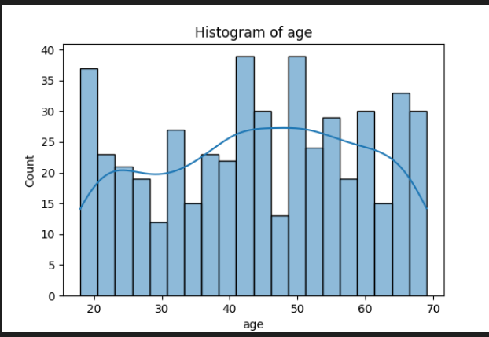

- Bar Plot → Gender counts.
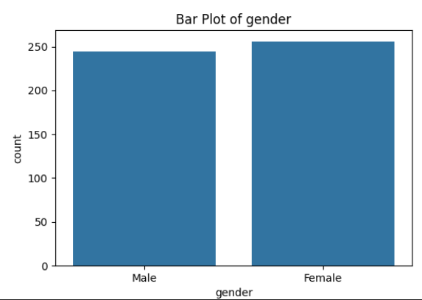
- Heatmap → Correlation among numerical features.
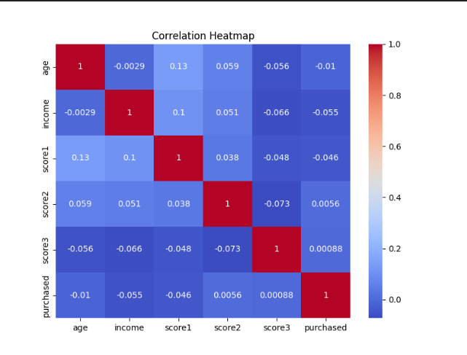

- Scatter Plot → Age vs. Income.
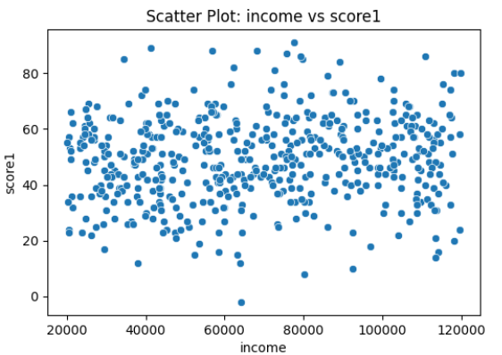
- Saved in plots/ folder.

4.6 Model Training & Metrics
- Models: Logistic Regression & Random Forest.
- Metrics saved in:
  - results/metrics_cleaned.csv
- Models saved in:
  - models/logistic_cleaned.joblib, models/randomforest_cleaned.joblib
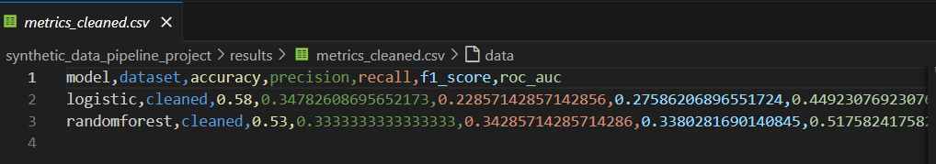

🔹 4. Reflections

Challenges
- Package/module imports were tricky (needed __init__.py and correct python -m runs).
- Matching augmentation function names (add_noise vs. augment_data).
- Ensuring models & metrics were actually saved.

Design Choices
- Chose class-based OOP for reusability.
- Used modular programming to keep pipeline scalable.
- Added logging for reliability.

Scaling Further
- Add more sophisticated augmentation (SMOTE, GANs).
- Expand to regression tasks (e.g., income prediction).
- Containerize with Docker for portability.
- CI/CD setup to run tests automatically when new code is pushed.

